Order Management System
Summary
The Order Management System is a distributed microservices application that processes customer orders through multiple stages: payment processing, inventory management and customer notifications.
Architecture Diagram
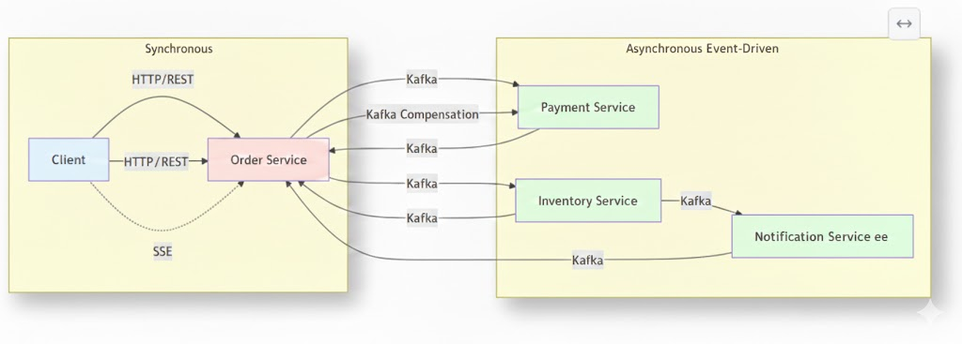
The architecture follows an event-driven Saga orchestration pattern to maintain data consistency across distributed microservices. In a successful flow, the Order Service acts as the orchestrator, transitioning the order from a PENDING state through a sequence of asynchronous steps—starting with PAYMENT PROCESSING, moving to INVENTORY RESERVATION, and concluding with a CUSTOMER NOTIFICATION—before marking the order as COMPLETED. However, to handle the "distributed transaction" problem, the system includes built-in compensating transactions for failure scenarios. If a downstream step like inventory reservation fails (e.g., INVENTORY_FAILED), the orchestrator triggers a rollback mechanism, such as a REFUND PAYMENT command, to undo previous successful actions and ensure the system returns to a consistent state, ultimately marking the order as CANCELLED. Postgres DB is used to persist the inventory and status of the order and items.
Server-Sent Events (SSE) is used for the server to push real-time, one-way updates to a client over a single, long-lived HTTP connection.

Success Scenario
1. Client → Order Service
Creates order with customer details and items
2. Order Service → Kafka
Publishes "order-created" event
3. Payment Service
Processes payment
Publishes "payment-completed" event
4. Inventory Service
Checks stock availability
Reserves items from inventory
Publishes "inventory-reserved" event
5. Notification Service
Sends order confirmation email
Publishes "notification-sent" event
6. Order Service
Updates order status to COMPLETED
Returns success response to client
Total Time: ~1.8 seconds
Status: Order COMPLETED ✓

Success Scenario: Order Created
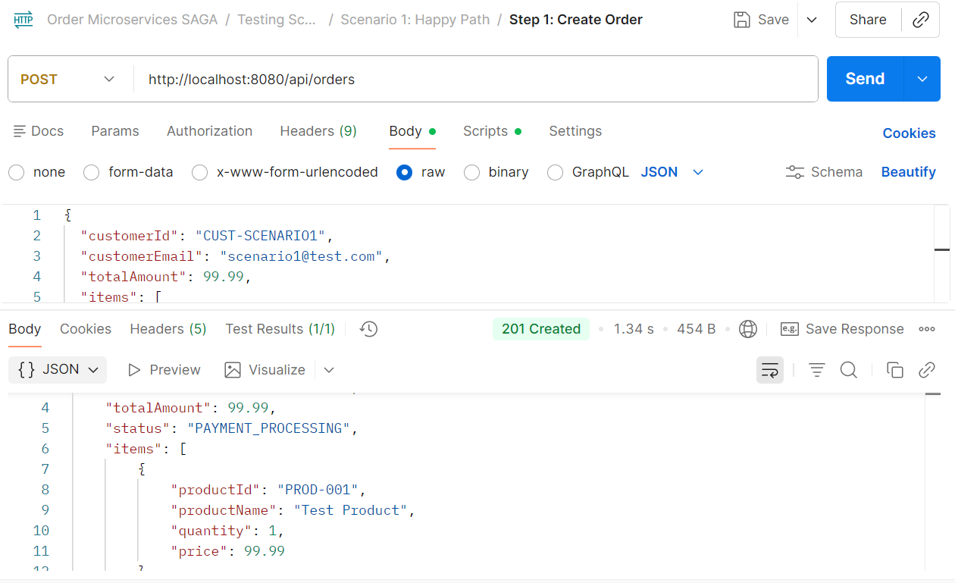

Inventory Reserved
Available quantity before
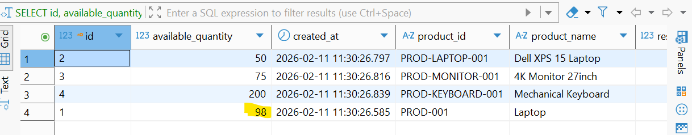
Available quantity after
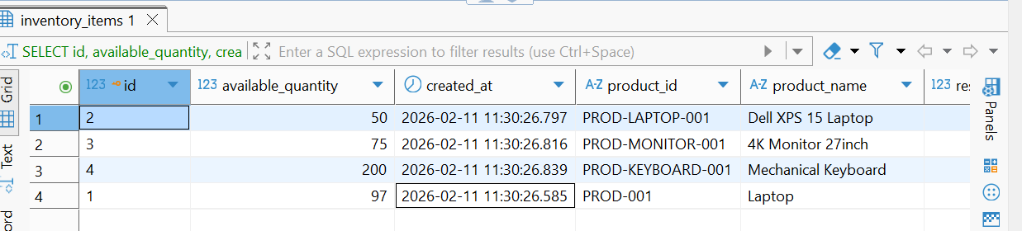

Failure Scenario with Compensation
When a step fails after previous steps succeeded, the SAGA pattern automatically triggers compensation to rollback the transaction:
1-3. [Same as success - payment completes successfully]
4. Inventory Service
Checks stock availability
✗ INSUFFICIENT STOCK
Publishes "inventory-failed" event
5. Order Service (COMPENSATION TRIGGERED)
Detects failure after payment success
Publishes "refund-payment" command
6. Payment Service
Refunds the payment
Publishes "payment-refunded" event
7. Order Service
Updates order status to CANCELLED
Returns cancellation response to client
Status: Order CANCELLED (Payment Refunded) ✓

Product does not exist
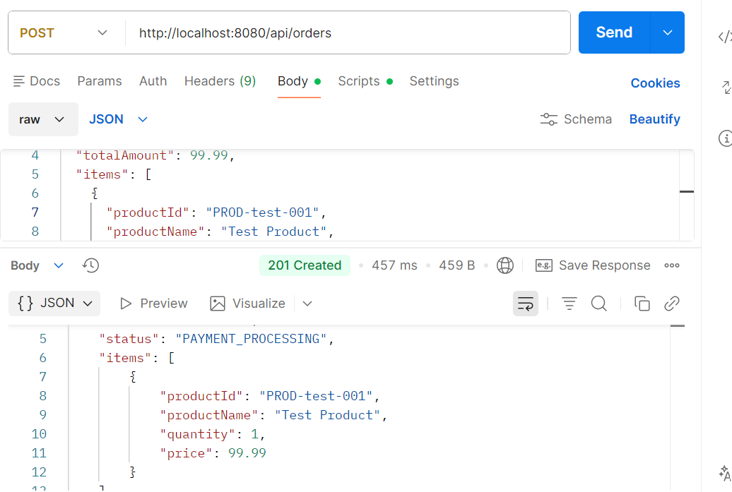

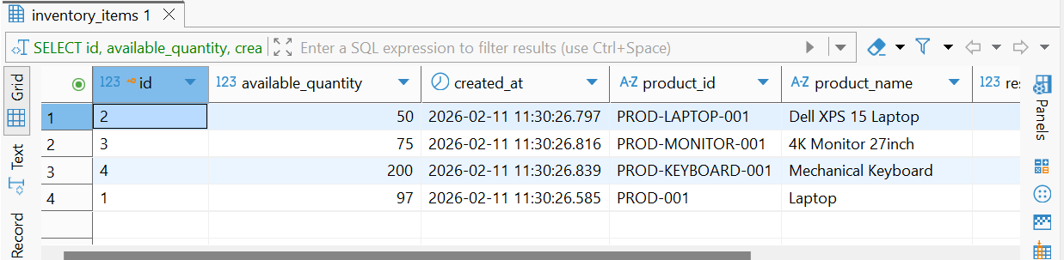

Insufficient stock Payment is refunded.
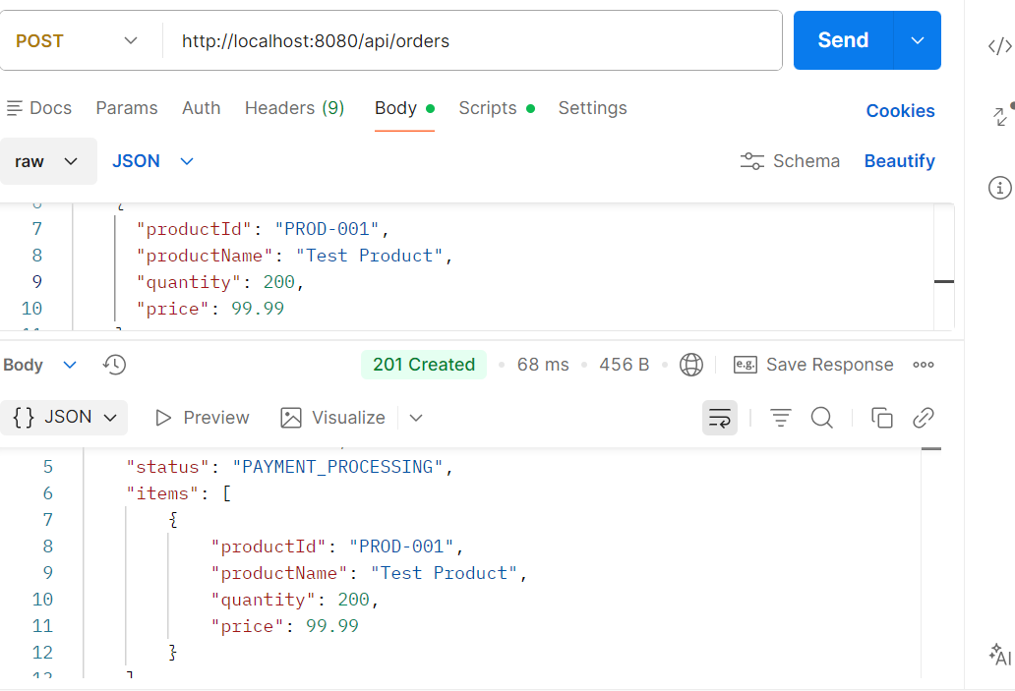
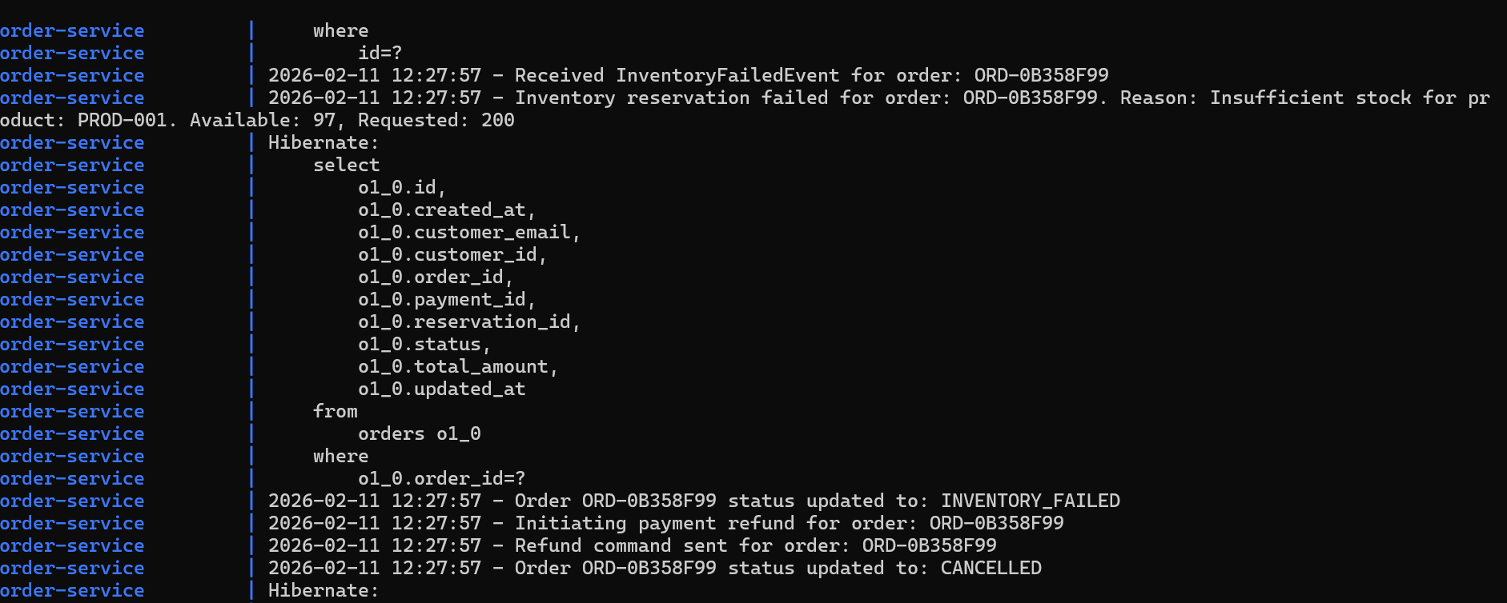

Payment gateway failed due to too many requests.
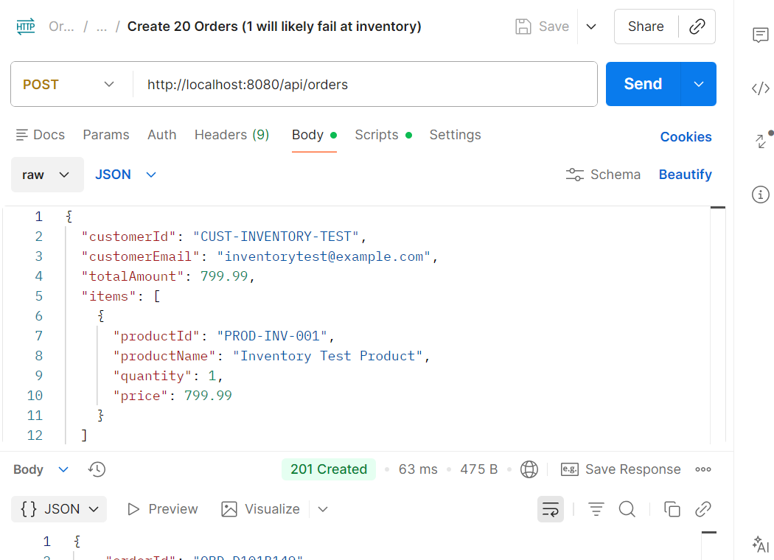
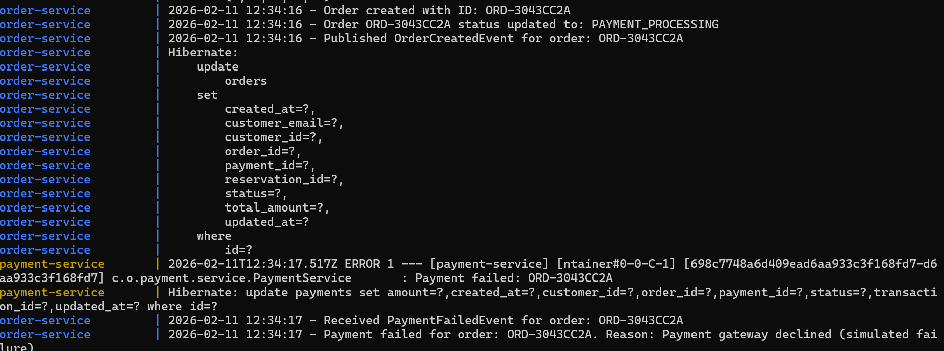
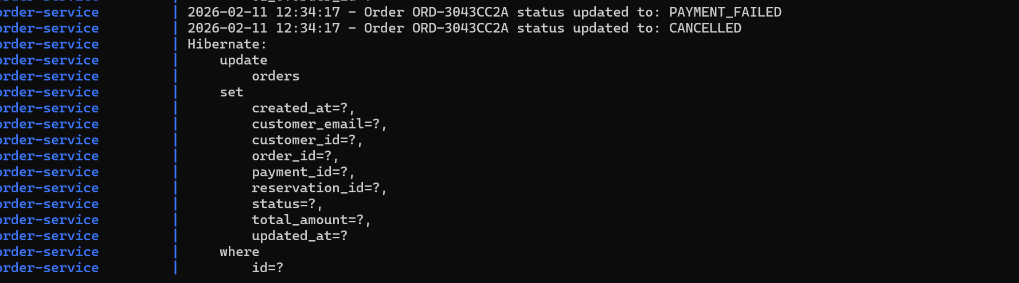

AI Tools Used: Claude
